Project Design Phase-II
Data Flow Diagram & User Stories

Date
Team ID | LTVIP2026TMIDS40430
Project Name | Empowering India: Analysing the Evolution of Union Budget Allocations for Sustainable Growth
Maximum Marks | 4 Marks

Data Flow Diagram (Standard flow) :
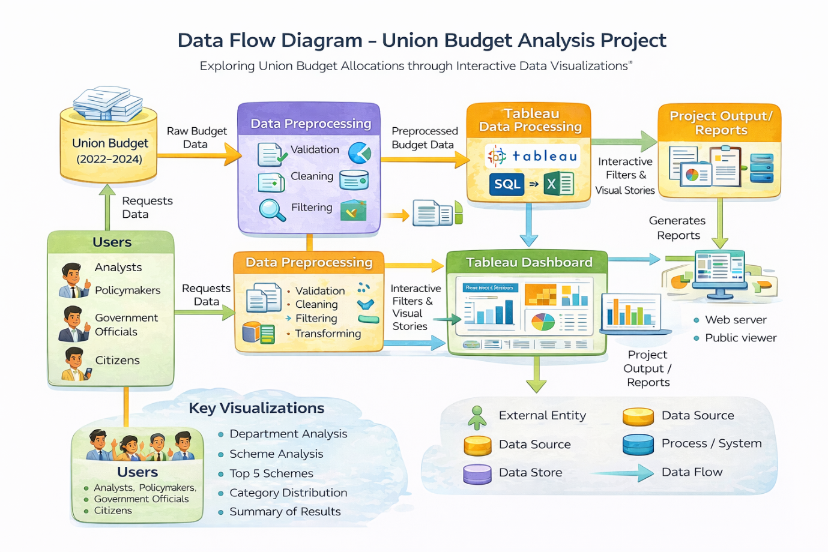

Data Flow Diagram (DFD) – Union Budget Analysis Project
Overview
The Data Flow Diagram (DFD) represents the systematic flow of data within the Union Budget Analysis Project. It illustrates how raw Union Budget data is collected, processed, transformed, and visualized using Tableau to generate meaningful analytical insights. The DFD provides a clear understanding of data movement between external entities, processes, data stores, and final outputs.
Level 1 – Detailed Data Flow
The detailed DFD includes the following major components:
- Data Source
The primary data source is the official Union Budget dataset, which includes:
- Ministry/Department
- Scheme Name
- Budget Estimates (2022–2023)
- Budget Estimates (2023–2024)
- Revised Estimates
- Category-wise classifications
This raw data is imported into the system for processing.

- Data Preprocessing
This stage ensures data accuracy and readiness for visualization. It includes:
- Data Validation – Checking for missing or inconsistent values.
- Data Cleaning – Removing duplicates and correcting errors.
- Data Transformation – Structuring data into suitable analytical format.
- Filtering – Selecting relevant years and required measures.
The processed data is then stored for visualization purposes.

- Tableau Data Processing
The cleaned dataset is imported into Tableau where:
- Measures and dimensions are configured.
- Calculated fields (if required) are created.
- Filters (Year, Ministry, Category, Scheme) are implemented.
- Aggregations (SUM, Growth comparison) are applied.
This stage transforms processed data into structured analytical visuals.

- Dashboard & Visualization Layer
The Tableau dashboard generates:
- Department-wise Budget Comparison
- Scheme-wise Budget Analysis
- Top 5 Schemes
- Category-wise Distribution
- Year-over-Year Growth Comparison
Interactive elements include:
- Filters
- Legends
- Tooltips
- Dual-axis visualizations

- Output & Reporting
The final output includes:
- Interactive Tableau Dashboard
- Downloadable Reports
- Visual Stories for Presentation
- Insights for Policy and Research
Users can access the dashboard through:
- Tableau Public
- Web Integration (if deployed using Flask)
- Shared dashboard links

Data Flow Summary
The overall data flow can be summarized as:
Official Union Budget Data
→ Data Collection
→ Data Cleaning & Transformation
→ Tableau Processing
→ Interactive Dashboard
→ Analytical Reports & Insights

Importance of the DFD
The Data Flow Diagram helps in:
- Understanding system architecture clearly.
- Identifying data dependencies.
- Ensuring transparency in data processing.
- Demonstrating structured analytical workflow.
- Supporting system documentation for evaluation and academic review.

Conclusion
The Data Flow Diagram for the Union Budget Analysis Project clearly demonstrates how raw financial data is transformed into interactive visual insights. By structuring the flow into logical stages—data collection, preprocessing, visualization, and reporting—the system ensures accurate analysis and effective decision-making support.

